**SOLANO COMMUNITY COLLEGE**

**MT 162, ROBOTICS**

Fall, 2018

SOLANO COMMUNITY COLLEGE

ROBOTIC SYSTEMS MT-162

**LAB 3: USER & JOG FRAMES**

**Catharine Crayne**

9/20/18

**OBJECTIVE**:

1. To learn how to setup a USER and JOG Frame.

**GROUP MEMBERS**

Diane

**MATERIALS**: Ruler or measuring tape, RoboGuide and Laptop, Fanuc Robot, Box

**PROCEDURE**:

1. Power up the robot controller. Place the robot in Teach Mode.
2. Turn on Teach Pendant and change the robot’s jog speed to 25%. Set the robot to jog in the WORLD coordinate system.
3. Go into the Frames Setup Menu, verify you are in the User Frame setup menu; if you aren’t in that menu, select OTHER. Make sure the entries for User Frames are all clear.
4. Follow the Procedure 8-3 on the handout and define a User Frame (#1) using the 3 point method.
5. Press the [SHIFT] + [COORD] keys to make sure you have selected your User Frame that you just setup. Jog the robot in the X, Y, and Z directions. How these directions different than those in the World Frame?
6. Now jog the robot in the W, P, R directions. How does this compare to the directions in the World Frame?
7. Now create a Jog Frame using the 3-point method. Procedure 8-4 may be useful.
8. Now go back into the Frames Setup Menu again, verify you are in the User Frame setup menu; if you aren’t in that menu, select OTHER. Clear the entries for User Frames and Jog Frames.

**Results – DATA**

Step 5: The X and Y axis was changed when we operated in the User Frame we just created. The X and Y axis now run between the coordinate points we recorded.

Step 6: During rotational moves the X, Y, Z positions do not move, and the actual direction of the rotational movement appears to be the same as WORLD.

**Observations**

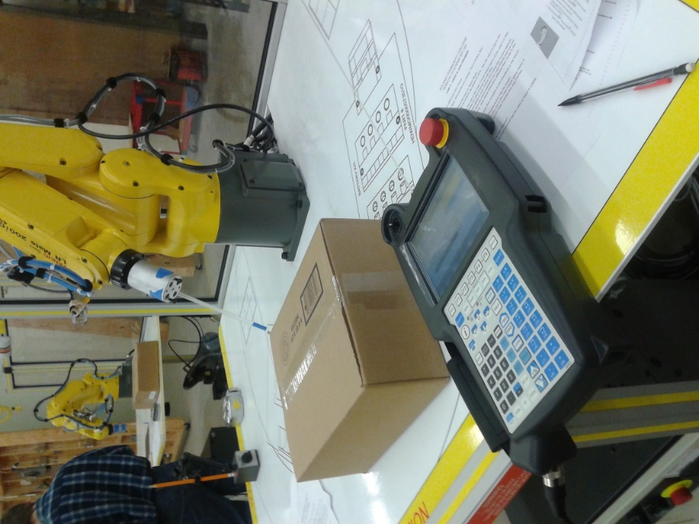 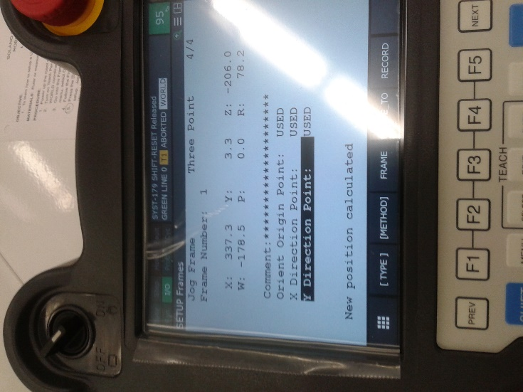

**Analysis Questions:**

1. Where is the USER frame 0 located?

*World Frame Origin – Center of J1 perpendicular at the intersection of J2 axis or center of J1 rotation to the height of J2 rotation*

1. Why would it be necessary to have more than one User Frame?

*It would be necessary to have more than one User Frame if the robot will be working on another object which is not in the same position or is not the same size/shape as the original object.*

1. Besides the 3 Point and Direct Entry methods, what other method can be used to teach a USER frame?

*6 point method*